|  |
| --- |
| SINTEF F24311- Restricted |

|  |
| --- |
| Report  CLC perspectives for Hessjøgruva AS ore deposit  Evaluation of the oxidized deposit from Hessjøgruva A/S, as candidate material for Chemical Looping Combustion  Author(s)  Yngve Larring  Thomas Kaleta Tommy Mokkelbost Jonathan Polfus |

|  |  |
| --- | --- |
| VERSION  Version 1.3 | DATE  2013-04-17 |
| AUTHOR(S)  Yngve Larring  Thomas Kaleta Tommy Mokkelbost Jonathan Polfus | |
| CLIENT(S)  Hessjøgruva AS | CLIENT’S REF.  Theodor W. Holmsen |
| PROJECT NO.  No.805672.00 | NUMBER OF PAGES/APPENDICES:  27/0 |
| ABSTRACT  In this project the potential of a new interesting mineral deposit has been investigated as an oxygen carrier in a new technology for power production with CO2 capture called Chemical Looping Combustion (CLC). The deposit consisting of mainly pyrite and magnetite is interesting since they form porous iron oxide materials under combustion with small amount of Cu with high surface area for enhanced gasification and combustion of fuel. The material cost is also favourable for CLC using coal where the material consumption is an issue. The preliminary testing of this material shows promising results when it comes to kinetics compared ilmenite which is the state of the art material. The oxygen carrier capacity can also be enhanced above the ilmenite capacity by removing different silicates (27%) from the active material. The reactivity towards CH4 is much better than all other "raw" material tested so far. Clogging effect has been observed under testing in fluidized reactors, better understanding of this effect can contribute to solve this issue; one may be improved calcination of the material avoiding overheating giving excess Zn on the surface. Material samples have been prepared through this project for use in large EU project called ÉCLAIR which has as an aim to demonstrate 1MW coal fired CLC system. This material is selected as a candidate material in project called ACCLAIM which is the continuation of ÉCLAIR which ended December 2012. | |

Table of contents

1 Background 4

2 Characterisation of the raw material 5

3 Testing of drilled samples 7

4 Testing of Cu concentrate (24%) 11

5 Optimal calcination of the mineral 12

6 Comparison of drilled samples and open source 17

6.1 Pre-treatment of the samples before TG testing 18

6.2 TG measurements 18

6.3 Kinetics 19

7 Testing of materials at SINTEF external cooperation partners 21

7.1 Testing at SINTEF 21

7.2 Testing at Chalmers 21

7.3 Testing at CISC 24

8 Summary and conclusion 25

# Background

This work is related to the large deposit of a mixture of Pyrite (FeS2), Pyrrhotite (Fe7S8), "zinc blende"- Sphalerite (ZnS) and Chalcopyrite (CuFeS2) mineral located in Holtålen municipal. The mining area has two fields, A and B. The A-field is deep (below ~400m) and rich in Cu and low in Zn, while the B-field is going fully to the open and is low in Cu and rich in Zn.

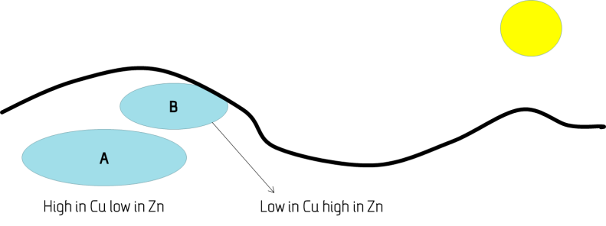

*Figure 1 Location of fields A and B.*

The local council has established a mining company called Hessjøgruva AS (2011), which aims at starting up a mining industry, connected to extracting Cu concentrate from the ore. Since the normal way of Cu extraction is costly and associated with restrictions on storage of waste etc. alternative use of the ore have been searched for.

Holtålen municipal administration connected SINTEF through their consultant inside mining Theodore W. Holmsen, to discuss if their mining product could be of interest in a new technology under development for power production with CO2 capture called Chemical Looping Combustion (CLC). The material was found interesting due to the Cu containing part of the Fe2O3 source after calcination. The Zn content gives some uncertainty since this can be slightly volatile unless reacted well with Fe2O3. A project was applied through *Innovasjon Norge*, for investigation of their ore as a product for CLC processes. The project was granted and aiming plan was made for preparing relatively small batches for testing in existing rigs in already established projects. Some internal testing was also planned at SINTEF for checking the performance of the material after calcination.

The material was found interesting as a candidate material for CLC where iron containing materials often have been used as a source for transport of oxygen between a combustion chamber (fuel reactor) and a re-oxidation chamber (air reactor) (see Figure 2). This material is circulating between the chambers by the help of a cyclone separating the particles from the gas stream and back to the other reactor. In the fuel reactor the fuel (coal, pet-coke, and natural gas) reacts with the oxygen from the circulating material resulting in combustion of the fuel. If the carrier matches the process parameter window a combustion product of mainly CO2 and H2O is obtained. The steam is condensed and CO2 is captured directly. In the air reactor the material is oxidized and a lot of heat is created which then is used towards a gas or steam turbine to create power. This power production with CO2 capture is still one of the best process with the lowest efficiency penalty for CO2 capture, since post gas separation is not needed which is often the most costly part in most suggested capture technologies.



*Figure 2 Schematic showing the principles of Chemical Looping Combustion (CLC)*

# Characterisation of the raw material

Some particles were analysed for better understanding of the material composition, and grain size of the different phases. Figure 3 shows a SEM picture of a section of the ore material as received. The different grey colours indicate different phases. In Figure 4 the elemental mapping of the material is shown on the same area as shown in Figure 3. The material has phases of Calcium Magnesium Silicates and Cupper Iron Sulphides with different compositions.

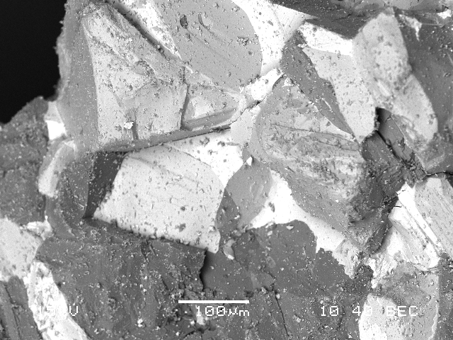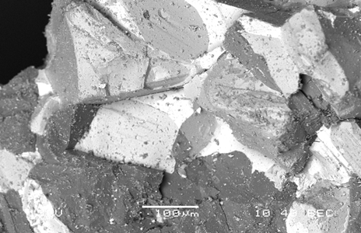

Fe7S8

(CaMg)O

CuFeS2

FeS2

CuFeS2

Fe7S8

Fe7S8

(CaMg)O

MgSiO4

Fe7S8

*Figure 3 SEM picture of a section of the ore material as received.*

# Summary and conclusion

From all the results shown above it is clear that

* The pre-treatment (de-sulphurization) of the pyrite material is very important for getting a good material; 660-760 °C seems to be the best de-sulphurization temperature.
* After desulphurisation a good sintering temperature should be found between 950-1100°C
* Test on drilled samples shows better performance than the eroded. Both drilled and eroded samples have higher capacity than the ilmenite for reduction time suitable for the CLC process in the range of 1min (Figure 28). But even at longer reduction time, at 800°C up-to 15 min (Figure 24) and at 1000°C up-to 5 min (Figure25), the samples shows better performance than ilmenite when it comes to oxygen transfer. Drilled samples with inert materials removed have also a higher final capacity than ilmenite for infinite reduction times under the tested condition.
* Gasification of the coal was found to be 15 times faster than ilmenite, reported by CSIC.
* The kinetics of the pyrite is far better than ilmenite towards conversion of CH4 and can be further improved removing inert materials. The CO conversion is found by SINTEF to be higher than ilmenite for both fresh and eroded deposit, while CISC claim that they have the same reaction rate (eroded sample).
* CISC found that the gasification of coal was clearly enhanced by the pyrite, it was found to be around 15 times faster for the pyrite (with high Cu content) than the ilmenite. Combustion efficiency was found to be between 92-100% depending on the composition of the batch (pyrite vs pyrrhotite and Cu content) and number of cycles. Materials performed better at 980 than 950°C. This gives an overall very positive result for Holtålen deposit.
* Fluidization of materials might also force us to remove the inert fraction since the difference in fluidisation properties might be a challenge, especially related to loss of material.
* Only one draw-back was found during the testing, related to de-fluidization, the reason for this behaviour is not proven jet. If Zn is causing the de-fluidisation (detected on surface after high temperature reductions) this case can be improved or maybe solved by;
  + Removed by flotation process
  + Better de-sulphurization and calsination process to avoid Zn going to the surface.
  + Remove Zn from the material after calsination

# Further needed work for Hessjøgruva deposit to develop an oxygen carrier for CLC

The Cu concentrate is one successful winner if the cost is not too high. The difference in density between the inert, Pyrite and Pyrrhotite phase after calsination is large. The fluidisation process for the different phases will therefore be very different. This suggests that one should aim at using and testing these phases more separate then what have been performed in this study. If the separation performed by flotation can also separate the Zn containing phases this will also most likely give a material without clogging effect which is important for the fluidisation processes in the CLC system. Hessjøgruva deposit is very interesting compared to similar deposit in Europe since it contain insignificant amount of unwanted elements found in the European deposit. The utilisation of this material is very limited since mining of the field has not started. The mining industry cannot be based on this new technology, but on the marked for Cu, but it would be very beneficial for the development of the CLC technology to have material with better performance than the ilmenite, which does not give a full combustion. The oxygen demand for ilmenite to get a full combustion is found to be around 15-20% depending on the operation of the CLC system. The extra need for oxygen is supported from an air separation unit. The ASU represent the biggest penalty for the CLC technology, which is one of the best technologies for power production by CO2 capture, it ability to be successful and in front of the other technologies for coal combustion depend on the establishment of a material that can give 100% combustion and have a relatively low cost, this is the case for the eroded deposit material tested, with less performance than the fresh samples. It should though be mentioned that this was for one cycle, but the drop in performance might be related to loss of materials in this process, this issue is still little unclear. One should though note that in this test was also not the inert removed and the different phases not separated, which could make it even more efficient.